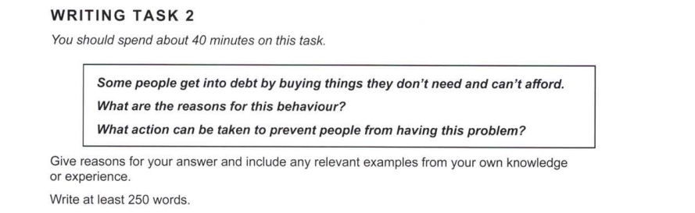

Essay Responses:

Retail therapy is a new way in which people are trying to ‘get better’ and try to heal themselves from bad mental health conditions. Indeed, this is a new problem which has led to some people buying things in the hope that they will be satisfied, with no consideration for their actual utility. But what are the exact causes of this phenomenon?

Firstly, there is an observable decline in mental health among the general population, with people often ignoring their emotions and trying to find ways to fix it by external means, without consulting therapists. Furthermore, when one is unaware of their mental state, they are more likely to make haphazard decisions – like impulsive purchases. This, compounded by the number of enticing advertisements that exist on social media platforms, inadvertently push such individuals to buy products that they may not even need. These advertisements may contain incorrect information that overestimates the efficacy of its products, thus fooling naive consumers.

What, then, could be done to solve this problem? Information campaigns and promoting mental health services are some of the top ways in which these situations could be avoided. Moreover, costlier items could have multiple checks before they are purchased, to avoid people buying them without proper thought. Furthermore, online platforms should have options that allow users to remove certain advertisements from their feeds, and report ones that make blatantly false claims. Using these methods could help prevent people from going into debt for these reasons.

In conclusion, we have discussed the causes and possible solutions for the issue of people making irresponsible purchases. If not addressed, this could have negative implications for our increasingly online society.